**How to install Arduino IDE on Raspberry Pi 4?**

**Reference guide:**

https://minicode.co.za/2019/10/12/correctly-installing-the-arduino-ide-on-a-raspberry-pi4/

**NOTE:**

Do not use the following command to install the Arduino IDE as a very old version will be installed:

sudo apt-get install arduino

**Step 1:**

Boot the Pi 4 and connect it to the internet.

**Step 2:**

Navigate to [www.arduino.cc](http://www.arduino.cc). Select the “Software” menu item (top, center of the home page) and then select “Downloads” sub option.

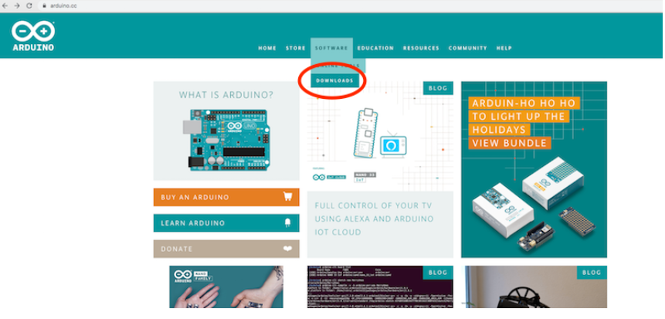

**Step 3:**

Select “Linux ARM 32 Bit” software package. The download confirmation screen will appear. Click “Just Download”.

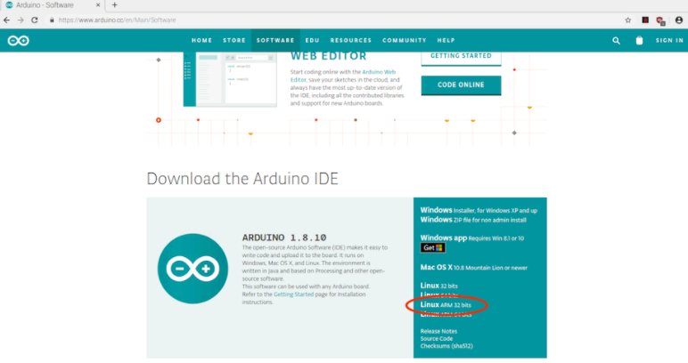

**Step 4:**

Open the command terminal window as the following instructions are carried out in the Terminal window. Type “**cd Downloads/**” and press <ENTER>.  The Arduino file you downloaded should be in this directory. You can list the contents of the directory by type “dir” or “ls” and pressing <ENTER>. Make sure you know the file name. The filename should be something along these lines: arduino-1.10.4-linuxarm.tar.xz. The numbers in the filename indicate the version.

**Step 5:**

The Arduino file is a compressed installation file which will need to be unzipped before installation.  Type “**tar -xvf arduino-1.8.10-linuxarm.tar.xz**” and press <ENTER>. If you have trouble completing the Arduino filename, type the first few letters of the filename, e.g. Arduino and press <TAB> and the Terminal window auto complete the filename.  The file will now be uncompressed. A list of files being uncompressed will scroll past. It might take a few seconds but less than a minute. When it is done the command line will reappear.

**Step 6:**

Next, move the installed files to the installation directory. Type “**sudo mv arduino-1.8.10  /opt**” and press <ENTER>.

**Step 7:**

Now run the install. Type “**sudo /opt/arduino-1.8.10/install.sh**” and press <ENTER>.  The installation will proceed, and a few installation messages will appear.

***NOTE:***

In the command terminal of the Raspberry Pi 4, do proper installation to get the data from the Serial Monitor of the Arduino IDE in the python code.